**ASSIGNMENT – 10**

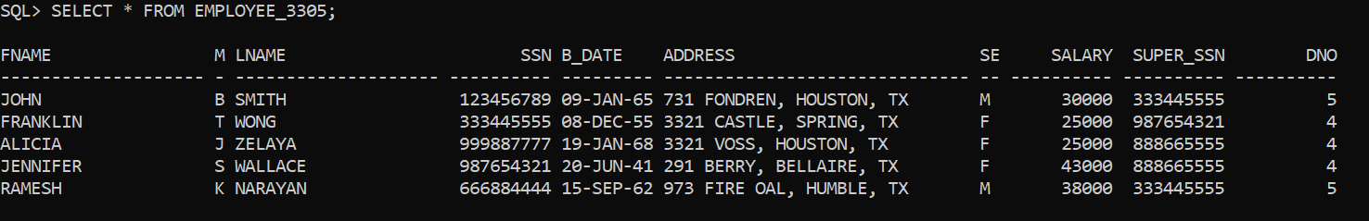

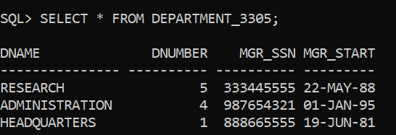

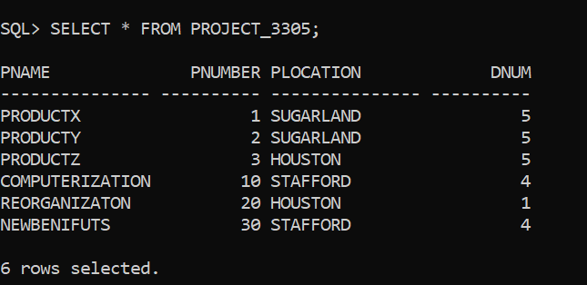

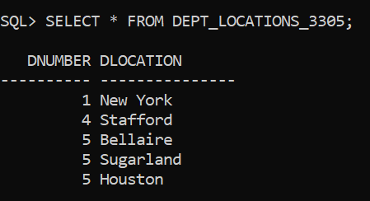

1. List the names of employees who work in departments located in 'New York'.



2. Retrieve the SSNs of employees who work in departments managed by 'John Doe'.

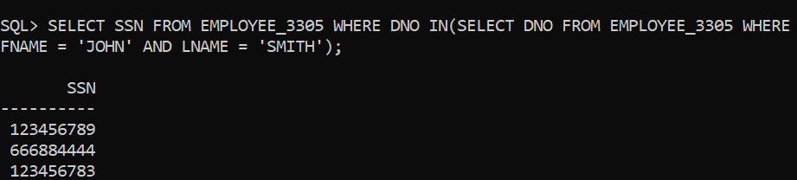

3. Find the names of employees who earn a salary greater than the average salary of their department.

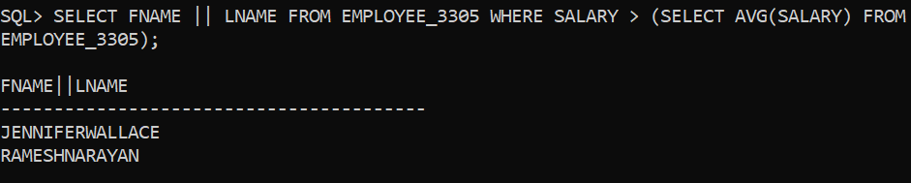

4. Retrieve the SSNs of employees who work on projects located in the department with Dnumber '5'.

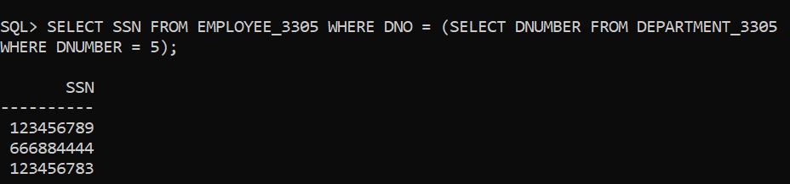

5. Find the names of employees who work on more than one project.

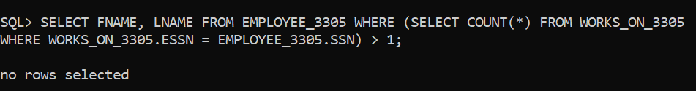

6. List the SSNs of employees who do not work on any project.



7. Retrieve the SSNs of employees who have the same manager as employee with SSN '987654321'.

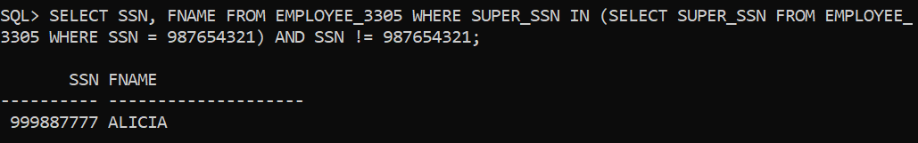

8. List the names of employees who work on projects with 'ProjectX' in the project name.

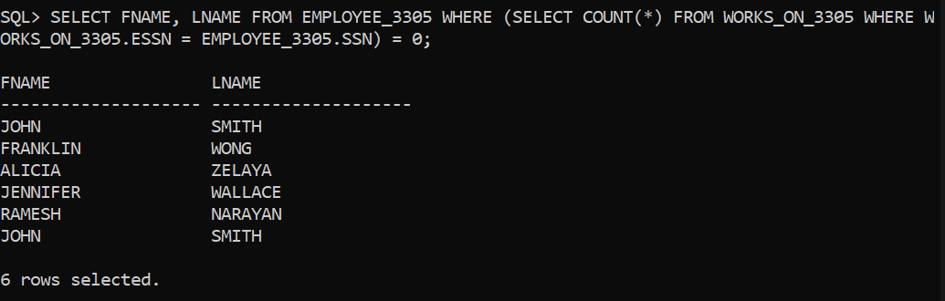

9. Find the SSNs of employees who don't work on any project.

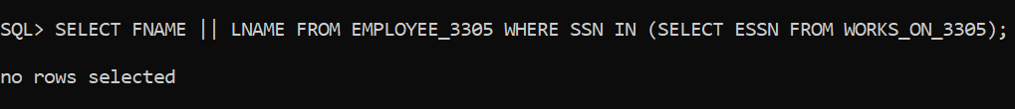

10. Retrieve the names of employees who have the same salary as employee 'Jane Smith

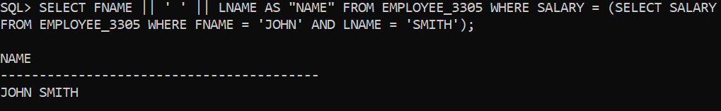

11. Retrieve the names of employees who earn a salary greater than the average salary of all employees.

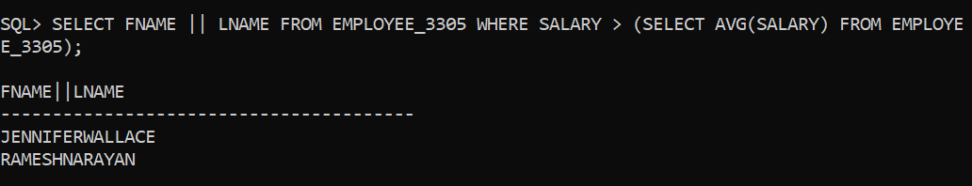

12. Find the names of employees who work on projects managed by 'John Doe'.

